### How to Use

1. Power the ESP32.
2. Connect it to Wi-Fi.
3. Open the Blynk app → view online device.
4. Add two buttons for **V0 (buzzer)** and **V1 (LED)**.
5. When fire is detected:
   * You’ll hear a buzzer, see an LED
   * Receive a Blynk notification
6. Use app buttons to turn off or re-enable alerts.

It will like this in Blynk app:

1. When connect ESP32 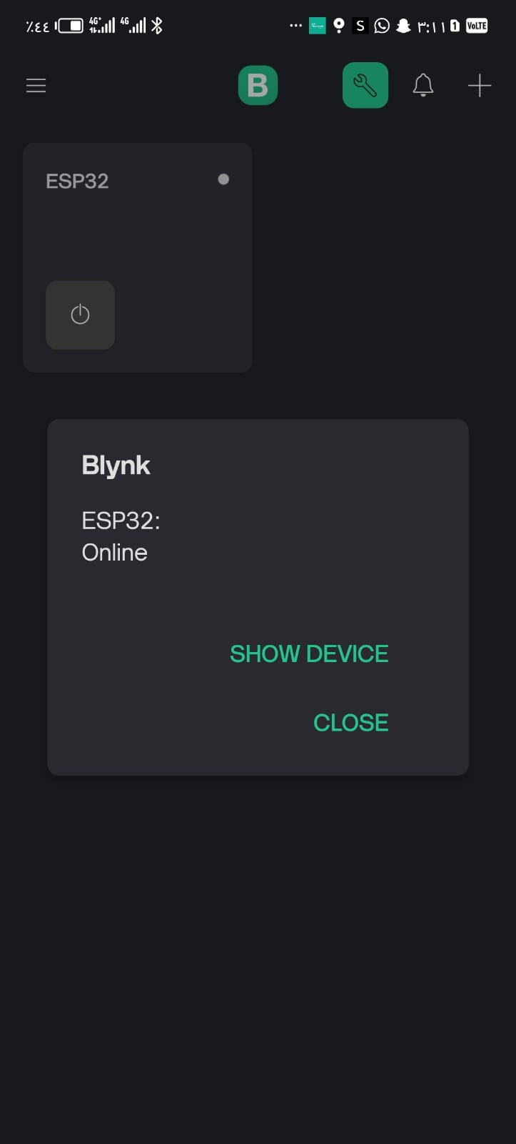
2. When detect fire

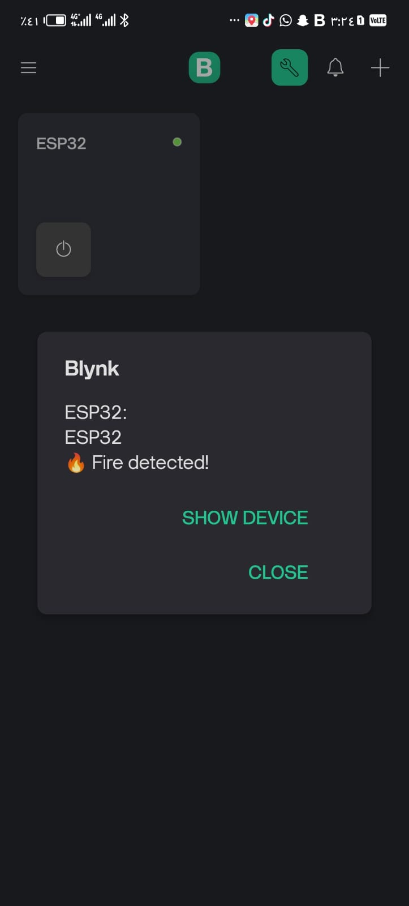

1. When the fire cleared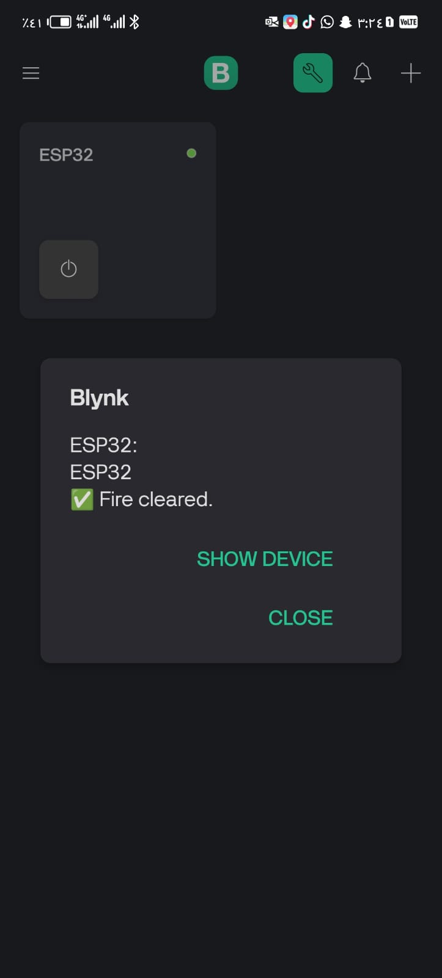
2. When ESP32 disenable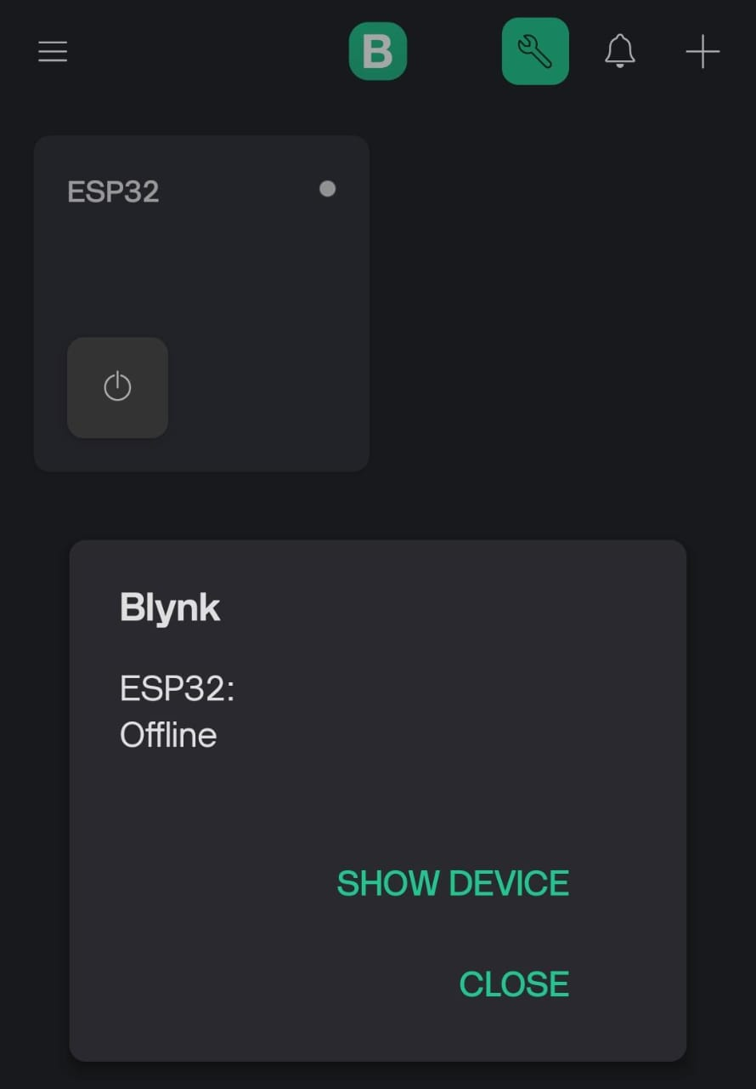

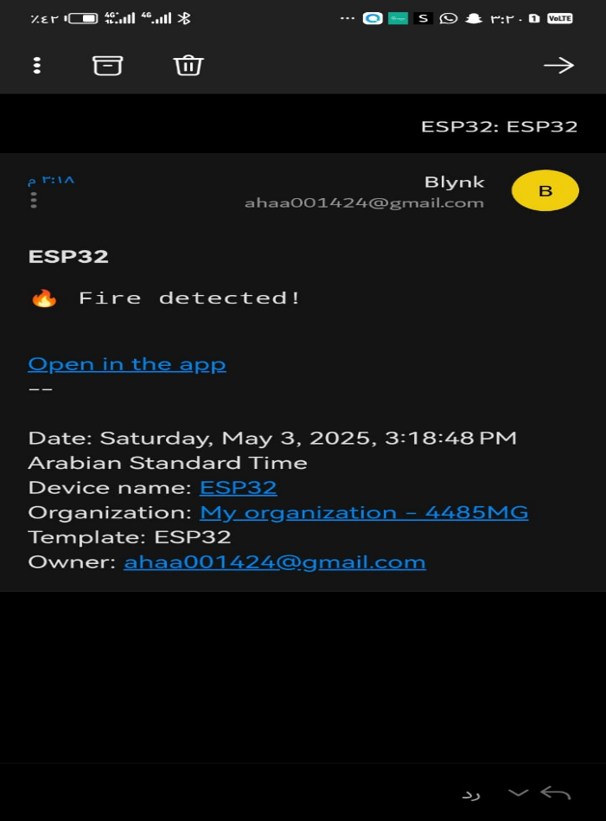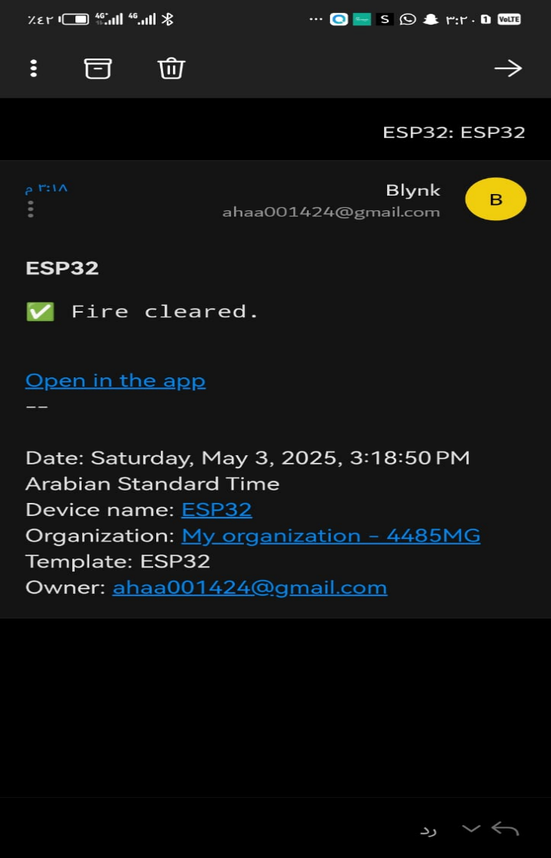sIn the email will be like this:

